<https://codeloop.org/python-opencv-introduction-and-reading-image/>

<http://www.imageprocessingplace.com/root_files_V3/image_databases.htm>

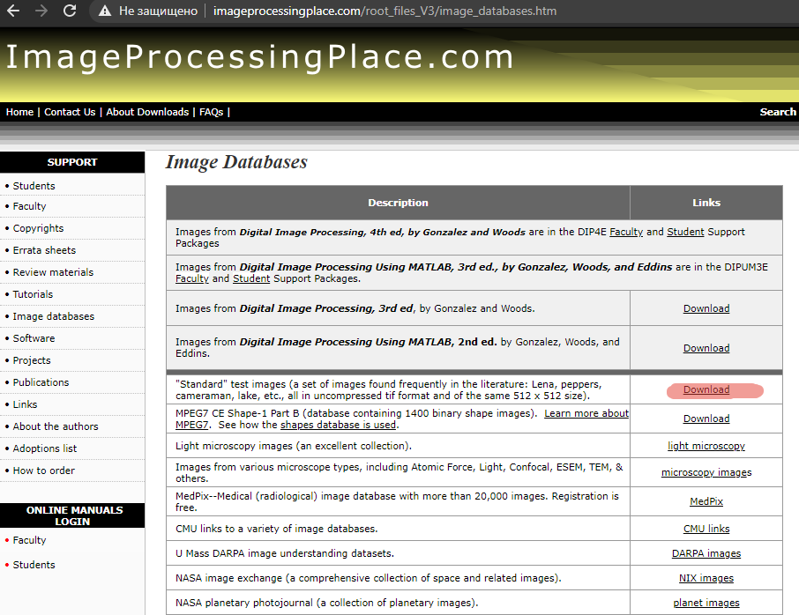

standard_test_images.zip

pip install opencv-python

--------------------------------------------------------------------------------------------------------------------------

# This line of code is for importing our OpenCV library.

import cv2

# In here we read the image and store that in the image variable

imgName = "lena_color_512.tif"

# This is for showing our image.

image= cv2.imread(imgName)

cv2.imshow('MyImage', image)

# It will display the window infinitely until any keypress (it is suitable for image display).

cv2.waitKey(0)

cv2.destroyAllWindows()